Name: . Section : .
. Date: .

PHYSICS 102
IMAGE IDENTIFICATION

Purpose: To practice interpreting images from other planets.

For each of the following images answer these questions:
  - For each letter marked on the image, what is the surface feature indicated? (1/2 point each)
  - How can you tell what features these are? (1 point each)
  - What geologic surface processes formed them? (1/2 point each)
  - What planet do you think this might be and why? (1 point per image)
  - In what order (oldest to youngest) were the features formed (if more then one) and why? (1 point per image)

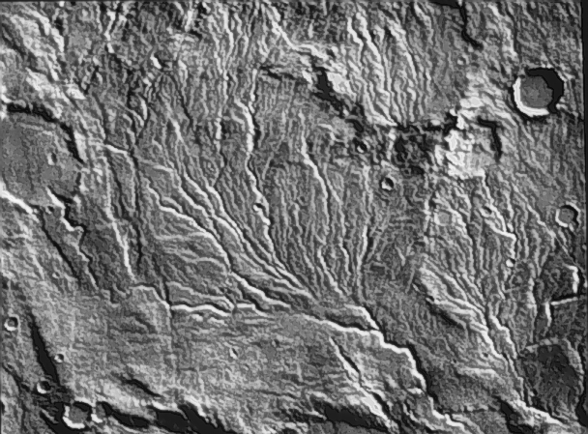

A

B

C
Figure 1
A: (a) River valley (b) sinuous, branching (c) erosion
B: (a) impact crater (b) perfectly circular with a raised rim and no obvious lava flow features (c) impact cratering
C: (a) impact crater (b) oval shape, but no evidence of overlapping calderas, raised rim, plus existence of other impact craters nearby (c) impact cratering
(d): Mars; erosion only takes place on Earth and Mars and there aren’t this many impact craters on Earth
(e): C, A, B; C is older than B because the water from B cuts the rim of C, C is older than B because it is more eroded. The relative ages of A and B are ambiguous.

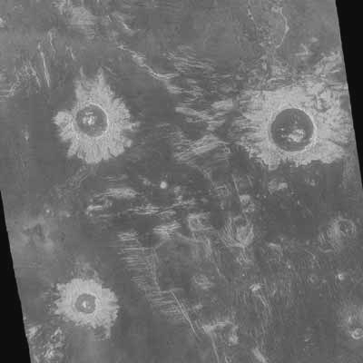

A
Figure 2

A: (a) impact crater (b) perfectly circular with a central peak and ejecta blanket visible (c) impact cratering
(d): Venus because the bright eject and dark floor of the impact crater suggest a radar image
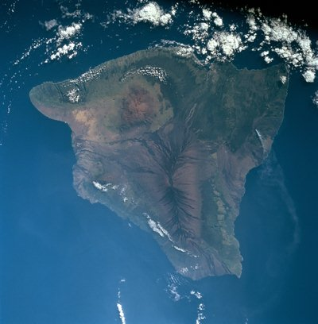

A
Figure 3

A: (a) volcano (b) central oval with dark, radiating flows. Flows are sinuous, indicating either water or lava, but, since they emanate from a single region and don’t branch, they are most likely lava flows. (c) volcanism
(d): Earth. The featureless area is likely water and the white, puffy areas are probably clouds. Water and clouds suggest Earth.
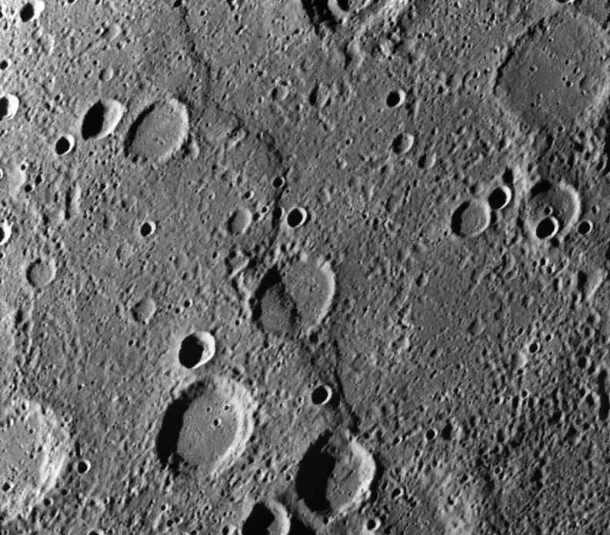

A

B

C
Figure 4

A: (a) impact crater (b) very cicular with a raised rim and no evidence of lava flows or overlapping calderas (c) impact cratering
B: (a) impact crater (b) perfectly circular with a raised rim and no evidence of lava flows or overlapping calderas (c) impact cratering
C: (a) ridge (b) higher on one side than the other, relatively straight, no branching (c) tectonics
(d) Mercury. Only Mercury has this many impact craters and these distinctive shrinking ridges.
(e) A, C, B. A is older than C because the ridge cuts through A. C is older than B because impact crater B is not affected by the ridge at all.

