Name: . Section : .
. Date: .

PHYSICS 102
IMAGE IDENTIFICATION

Purpose: To practice interpreting images from other planets.

For each of the following images answer these questions:
  - For each letter marked on the image, what is the surface feature indicated?
  - How can you tell what features these are?
  - What geologic surface processes formed them?
  - What planet do you think this might be and why?
  - In what order (oldest to youngest) were the features formed (if more then one) and why?

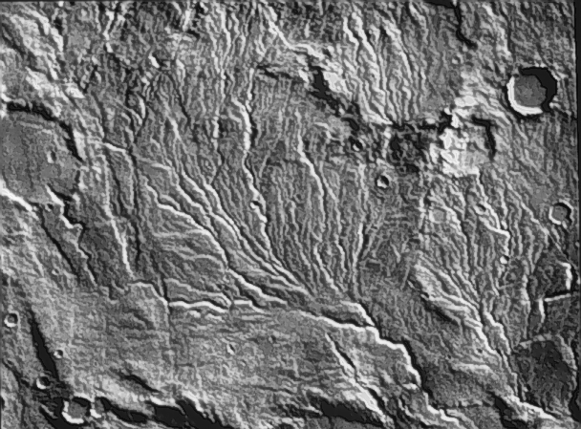

A

B

C
Figure 1

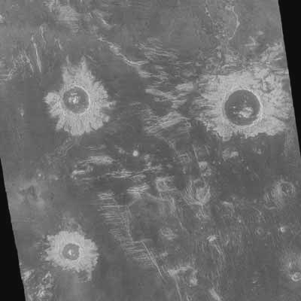

A
Figure 2

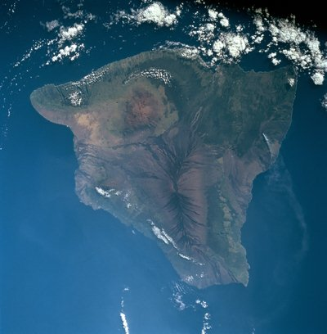

A
Figure 3

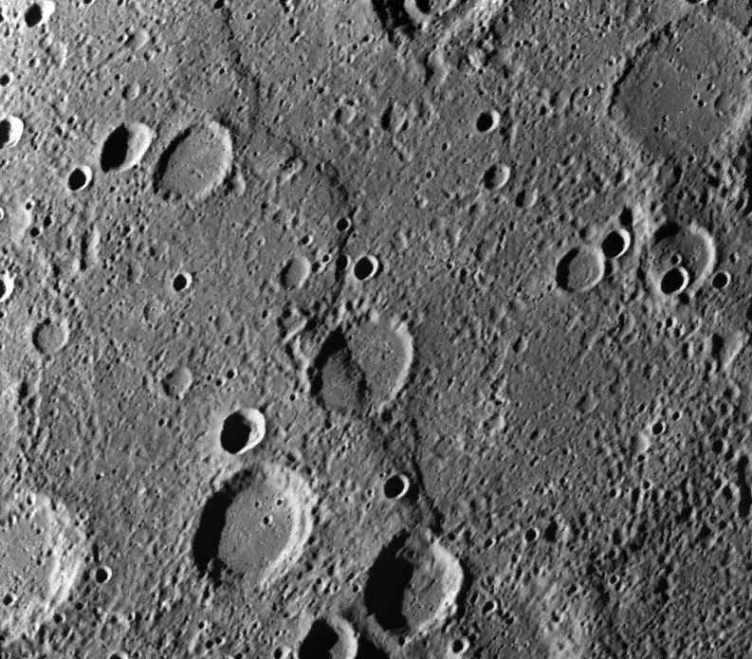

A

B

C
Figure 4

